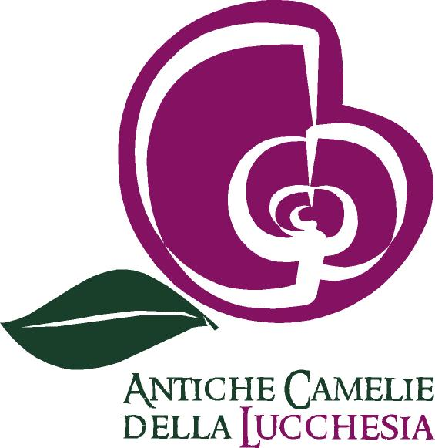

**Our History**

Since their arrival in Italy, around the end of the 18th century, vegetables that are part of the genus Camellia L. have had great success as ornamental plants both for their adaptability to our climate and their beauty, due to their evergreen foliage and breathtaking flowers. But what most caught collector’s attention was how easy you could obtain new variants with even more flamboyant flowers from the first species to ever arrive in Italy (Camellia japonica L.). Tuscany had a particularly big number of enthusiasts: with time they created many cultivars (variants created by people) and they also imported many more from other Italian regions and from abroad. These cultivars were then planted in the gardens of the most prestigious villas of Lucca, creating a new craze, the “camelliamania”, which reached its climax around mid of the ’800. These plants, that became monumental, still represent to this day a priceless asset for both beauty and rarity: the hundreds of camellias in these gardens and parks, in addition to gifting us with outstanding flowerings still remind us of individuals and facts of those times, thanks to their names. It is with the aim to preserve this notable botanic heritage, since some cultivars only have one specimen, that we created the Camellietum, which houses every cultivar that took part in the history of Tuscany in the ‘800. The area that we chose to use for this project — a terracing at the slopes of Monte Serra — is quite adequate, both for its microclimate, the abundance of water and the soil conformation. In March of 2005, alongside some local and international authorities, such as the president of the International Camellia Society, Mr. Gregory Davis, and a delegation from Japan, in particular Mr. Kataro Tanimoto, president of Exporter’s Tea Association of Shizuoka, that has been collaborating with us to organize the festival, the first specimen was planted. The Camellietum initially occupied four terraces, structured to also give it a didactic purpose: at the entrance you could find single flower cultivars and a few other species beside C. Japonica, in order to give the visitor a rough idea of what the genus Camellia is, on the second terrace where semi-double flower camellias were housed, and finally the last two terraces had double flower specimens. In 2006 the Camelieto, as it is commonly called, comprehend around 150 specimens and 120 different cultivars; in March of that same year Doctor Andrea Dietrich, director of the Pillnitz Castle (Dresda, Germany), housed in the garden a plant that came from the very famous and valuable mother plant in Germany.

In the two following years the Camellietum went through a slow but constant growth in number of plants and cultivars, reaching, in March 2008, 250 specimens and about 200 cultivars, such as Aspasia, Stella Polare (North Star) and Stella di Compito (Star of Compito), who are at risk of extinction. In the same year Centro Culturale Compitese, through a contribution from the administration of the Capannori municipality, purchased a collection of antique camellias. Since October 2008 the Camellietum has drastically changed its structure and essence: its surface has grown from 2000 to 7250 square meters and, with its last plants housed in March 2011, it has gone from 250 specimens and 200 cultivars to 1000 plants and 725 cultivars, not only from Tuscany, and mostly from Lucca, but also from all parts of Italy and some from countries in and outside Europe. Recently a new project of redevelopment, co-financed by Regione Toscana and the Capannori municipality, which arranges for the improvement of infrastructures of service to grant a better control, maintenance and usability of the Camellietum.

In 2015 we created a new area dedicated to camellias from the Pilnitz Castle, that have been in the “Antiche Camelie della Lucchesia” exhibit for more than 20 years.

**Garden Of Excellence**

Camelietum Compitese is by far the most visited camellia garden in Italy. It is a member of the International Camelia Society, in 2016 it received the prestigious title of Garden of Excellence, an award that only a few green areas in the world can show off. There are various requisites to be considered for this nomination, some are mandatory, others optional. Among the mandatory ones you’ll find regular opening hours to the public, a minimum of 200 cultivars, a registry with all the camellias and their location, signs on the most notable ones, a system to grant agricultural information to anyone, being part of the International Camellia Society, availability of the International Camellia Register to be consulted by visitors.

Some of the optional, but desirable, requirements are research programs on camellia colture, shows or displays during flowering season, demonstration of good agricultural practices, a collection of literature related to camellias, the option to purchase the cultivars shown in the garden. Every year thousands of people visit the Camellietum, from many parts of Italy but also from other European countries , above all Germany and Austria, especially during the Antiche Camelie della Lucchesia Exhibit that takes place in the first three weekends of March, in Pieve di Compito and Sant’Andrea di Compito.it has now become a yearly engagement, but every year it is able to renovate itself and attract more and more visitors to these two beautiful villages in Capannori. The Camellietum, other than being a destination for camellia enthusiasts and a research center for universities and botanists, is a park that lends itself, as already demonstrated in many occasions, to host musical and theatrical performances, meetings, press conferences in an amazing location.

**The Project**

The project for Camellietum Compitese (Camellietum) was born from the will to offer visitors the chance to learn about the genus Camellia from a botanic point of view, of its propagation , its history as well as its spread across the area of Compito from the 1800s till now, with the intention of creating a germplasm bank of these ancient cultivars in order to grant their preservation through time. The area chosen for this park is quite a suggestive place, historically organized and confined by stone walls, its extension was about 1000 square meters. These walls have been restored and kept because they represent elements of value and tradition for this territory . Particular attention was lended to choosing the materials, which had to blend with the natural and wild surroundings, and also to build in the traditional way since this project was inserted in order to look like part of the scenery. The terracing are not linked to one another, but they distinct four independent spaces on different levels to which you can gain access trough the road to Monte Serra and a little path about 200 m after the fountain in Capo di Vico.

**Around The Camellietum**

Since 2020 Centro Culturale Compitese has started reclaiming some abandoned areas near the garden, fin doing so they some themed gardens: one dedicated to *C. sasanqua*, which flowers during fall, to *C. higo* also known as the Samurai Camellia, and finally *C. sinensis,* the tea plant*.* Furthermore, a didactic area has been installed, where you can better understand the world of camellias. Right now a new area is being prepared, one dedicated to *C. reticulata*, dark, fragrant, small camellias. Some old paths have been restored, alongside some picnic space, ideal for healthy hikes in nature.

**Adopt a Camellia!**

You too can adopt a plant housed in Camellietum Compitese!

If you adopt a camellia you will help us with the maintenance and expansion of the garden. A personalized sign will be put in front of the plant of your choice (for more information write an email to info@camelielucchesia.it)

Segreteria “Antiche Camelie della Lucchesia”

c/o Coop. Centro Culturale Compitese P.IVA 00443210463

Via Fonda 1, 55065 Pieve di Compito Capannori (LU)

Tel/Fax . 0583 977188 / 366 2796749

[info@camelielucchesia.it](mailto:info@camelielucchesia.it) [www.camelielucchesia.it](http://www.camelielucchesia.it/)

Albo Società Cooperative A118535